1.Build Array from Permutation:
#code:
class Solution {
public int[] buildArray(int[] nums) {
int[] ans = new int[nums.length];
for (int i = 0; i < nums.length; i++) {
ans[i] = nums[nums[i]];
}
return ans;
}
}

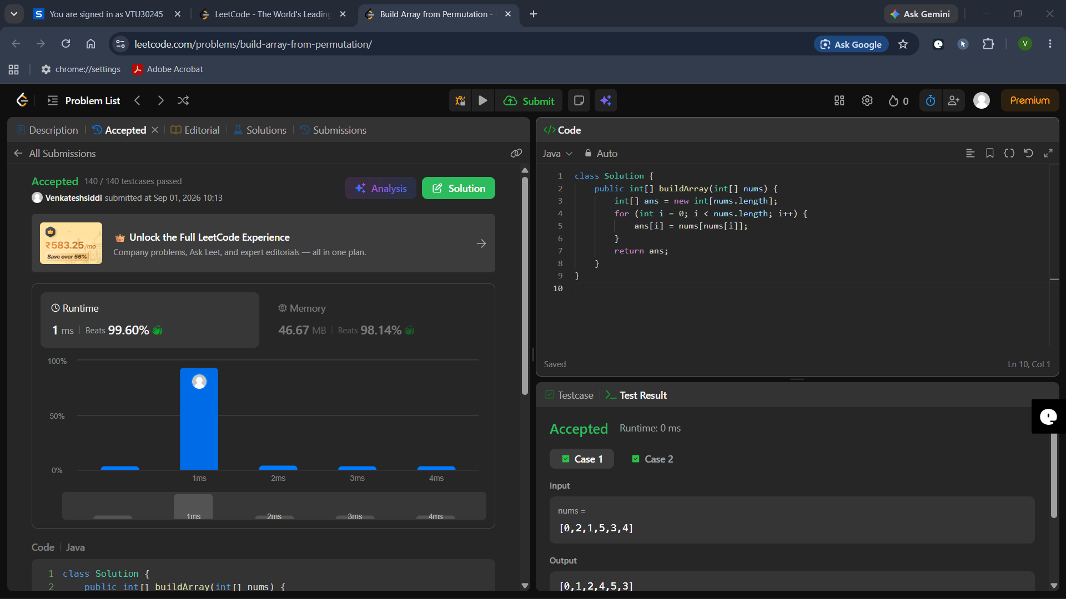

2. Shuffle the Array:
#code:
class Solution {
public int[] shuffle(int[] nums, int n) {
int[] result = new int[2 * n];
for (int i = 0; i < n; i++) {
result[2 * i] = nums[i];
result[2 * i + 1] = nums[i + n];
}
return result;
}
}

